FUEL SUBSIDY INCIDENCE BEFORE NIGERIA'S 2023 REMOVAL:
A QUAIDS ANALYSIS OF 2023/24 HOUSEHOLD DATA

by
Francis Phillip

A thesis submitted to Johns Hopkins University in conformity with the requirements for the degree of Bachelor of Arts in Moral and Political Economy

Baltimore, Maryland
May 2026

© 2026 Francis Phillip
All rights reserved

Abstract
Nigeria's May 2023 fuel subsidy removal eliminated a ₦4 trillion fiscal burden (2% of GDP) but triggered petrol price increases exceeding 160%. This thesis examines the distributional welfare impacts using household survey data from 2012/13 to 2023/24, replicating and extending Okereke et al. (2024)'s Quadratic Almost Ideal Demand System (QUAIDS) analysis to Nigeria's first post-reform household data. Methodologically, I validate the QUAIDS framework in R, demonstrating that demand elasticities are robust across software platforms (own-price elasticities match within 5%). I construct a proxy consumption aggregate for the 2023/24 wave, achieving strong rank-order preservation (Spearman ρ = 0.81) suitable for distributional analysis despite official aggregates' unavailability. Empirically, I find fuel subsidies were highly regressive: the richest quintile captured 60% of petrol spending within energy budgets versus the poorest 50%'s 25%. Subsidy removal triggered asymmetric substitution—kerosene access collapsed 59% (55.2% to 22.5%), forcing poor households to exit modern fuel markets while wealthy households maintained pre-reform consumption levels. Nigeria's post-reform cash transfers proved inadequate and poorly targeted. I recommend three compensatory policies: conditional cash transfers for the bottom 40%, transportation subsidies supported by infrastructure investment, and refinery rehabilitation. These findings inform debates about balancing fiscal sustainability with social protection in developing country subsidy reforms.
Primary Reader and Advisor: Prof. Simon Halliday
Secondary Reader: Prof. Healan Gaston

Acknowledgments
I am deeply grateful to my primary advisor, Professor Simon Halliday, for his invaluable patience, guidance, and mentorship throughout this project. I also could not have completed this thesis without the support of Professor Healan Gaston and Dr. Bridget Diana, who guided me through the thesis writing process with care and insight.
I am indebted to Professor Chukwumerije Okereke and his research team—Chukwuemeka Emenekwe and Uchenna Nnamani—for their generous assistance with the replication process and for methodological assistance that proved essential.
My thanks also extend to Dr. Corrigan for his patient assistance with coding challenges; to Francisco Perez Marsilla, my writing tutor, for his meticulous in-line edits; to Professor Roundtree for shaping my preliminary research on this topic; and to Professor Jeanne-Marie Jackson for providing thoughtful feedback at my thesis defense.
This research was inspired by conversations with Nigerians affected by the May 2023 subsidy removal, whose experiences grounded my analysis in the lived realities behind the data. It also builds on years of mentorship from educators who nurtured my early research aspirations. I am grateful to Dean Kim J. Nickerson, SRI Coordinator Brittney Robinson, and Professor George Kintiba at the University of Maryland, College Park; and to Professor Entela Xhane, Professor Jignasa Rami, Professor Barabra Leitherer, Professor Pankaj Dwarka, Professor Amy Wilson, Executive Director Adrianne Washington, Dr. Sunni Solomon, and Jeffrey Wright at the Community College of Baltimore County for believing in my potential and encouraging my academic journey.
Finally, I am forever grateful to my family for their unwavering love and support.
Contents

Abstract ii
Acknowledgments iii
List of Figures vii
Introduction 1
Contribution and Scope 3
Roadmap 4
Chapter 1: Background 5
1.1 Theoretical Framework 8
1.1.1 Nigerian Fuel Price Shock: A Concrete Example 9
1.1.2 The Almost Ideal Demand System (AIDS) 13
Chapter 2: Data, Methods and Results 17
2.1 Data Sources 19
2.2 Replication Framework (Waves 2-4) 20
2.3 Extension Framework (Wave 5) 24
2.4 Results 26
2.5 Discussion 30
2.5.1 Replication Challenges and Methodological Differences 32
2.5.2 Scope Limitation: Cash Transfer Analysis 33
2.6 Limitations 34
2.7 Conclusion 35
Chapter 3: Policy Recommendations 36
3.1 Policy #1: Conditional Cash Transfers 37
3.2 Policy #2: Transportation Subsidies Supported by Infrastructure Investment 41
3.3 Policy #3: Refinery Investment to Reduce Import Dependence 45
3.4 Limitations and Future Studies 50
Conclusion 52
Key Findings Recap 52
Policy Implications 53
Limitations and Future Research 54
Final Reflections 55

List of Tables

Table 1.1.1: Measure and Interpretation of Key Terms in AIDS 15
Table 2.2.1: Replication Comparison—My Results vs. Okereke et al. (2024) 22
Table 2.3.1: Overall Fit of Wave 4 Proxy Consumption Aggregate 25
Table 2.3.2: Distributional Match Between Official and Proxy Wave 4 Consumption Aggregate 26
Table 3.3.1: Key Nigerian Labor Market Indicators: Q4 2022-Q2 2024 48

List of Figures
Figure 1.1.1: Income and Substitution Effects—Nigerian Fuel Subsidy Removal 11
Figure 2.4.1: Energy Access Rates by Fuel Type 27
Figure 2.4.2: Within Energy Budget Shares by Quintile 28
Figure 2.4.3: Concentration Curves for Energy Goods (Wave 4) 29
Figure 2.4.4: Expenditure Shares by Income Decile (Wave 4) 30
Figure 3.3.1: Nigeria’s Trade in Oil Products (2000-2023) 46

Introduction

On May 29, 2023, Nigeria’s newly inaugurated President Bola Tinubu announced in his first official address: "fuel subsidy is gone." Within 48 hours, petrol prices surged over 160% nationwide, with states like Borno experiencing an increase of ₦199 to ₦557 per liter—a 195% increase. This abrupt end to the fuel subsidy triggered nationwide protests, transportation disruptions, and a sharp cost-of-living crisis. Tinubu's decree ended decades of fuel subsidies that had cost Nigeria over ₦4 trillion in the year 2022 (approximately 2% of GDP), a fiscal burden that international financial institutions and domestic policy analysts criticized as unsustainable. Yet, while subsidy removal promised to free up resources for education, healthcare, and infrastructure investment, its immediate aftermath also proved costly. It exposed millions of households to severe economic hardship, raising urgent questions about who bears the burden of such reforms and whether compensatory policies can protect vulnerable populations.
This thesis examines the distributional welfare impacts of Nigeria's 2023 fuel subsidy removal using household survey data spanning 2012-2024. More specifically, it asks: who bears the economic burden when subsidies end, and what is the precise nature of that burden? Answering this question requires understanding not only how much fuel prices increased in the wake of subsidy removal but also the wider web of consequences created by the policy. This includes factors such as how different income groups adjusted their energy consumption in response, whether households could substitute toward alternative fuels, and what non-monetary welfare costs (time burdens, health impacts, reduced service quality) accompanied these behavioral changes. The existing literature on fuel subsidy reform in developing countries has focused primarily on fiscal sustainability and macroeconomic impacts, with less attention to distributional welfare consequences measured using observed post-reform household behavior. Recent studies simulate potential impacts using pre-reform data and demand system models, but no research has examined Nigeria's 2023 reform using actual post-removal household expenditure data. This gap is critical: understanding distributional impacts is essential for designing compensatory policies that protect vulnerable populations while achieving fiscal consolidation goals.
My analysis reveals two major findings. First, fuel subsidies were highly regressive, with the richest income quintile capturing 60% of petrol subsidy benefits while the poorest quintile received just 10%. Concentration curves show that the top 10% of households consumed 35% of total petrol expenditure, while the bottom 50% accounted for only 25%. Second, the 2023 subsidy removal triggered dramatic changes in energy access. Kerosene access collapsed by 59% (from 55.2% to 22.5% of households), while petrol access rose modestly (from 48.2% to 56.6%). Given that pre-removal data (Wave 4) shows kerosene concentrated among poor households and petrol among wealthy households, this pattern suggests asymmetric impacts across income groups. These findings inform ongoing policy debates about whether Nigeria can pursue fiscal sustainability while protecting its most vulnerable citizens from the distributional consequences of economic reforms.
Contribution and Scope
This thesis makes three contributions to the literature on fuel subsidy reform. Methodologically, I replicate and validate the Quadratic Almost Ideal Demand System (QUAIDS) framework of Okereke et al. (2024) using R rather than Stata, demonstrating that core demand elasticities (which determine welfare impacts) are robust to software and minor specification differences. Own-price elasticities are within 5%, validating the demand response mechanism. Empirically, I extend this framework to analyze the newly released 2023/24 wave of Nigeria's General Household Survey (GHS-Panel)—the first nationally representative household data collected after subsidy removal. Because official consumption aggregates for this wave remain unavailable, I construct and validate a proxy consumption measure following standard Living Standards Measurement Study (LSMS) methodology, enabling descriptive analysis of energy access patterns and budget share distributions across income groups. For policy, I translate these empirical findings into concrete recommendations for Nigeria's evolving subsidy reform landscape, proposing a tripartite approach: conditional cash transfers, transportation subsidies supported by infrastructure investment, and strategic refinery rehabilitation.
The scope of this thesis is deliberately limited. I do not estimate a full QUAIDS demand system on Wave 5 data, as the proxy consumption aggregate (which overestimates by 48%) would create unreliable structural coefficients. Instead, I use Wave 5 for descriptive comparison of energy access rates and budget compositions relative to pre-reform waves. I do not simulate cash transfer schemes, as Okereke et al. do not provide sufficient methodological detail to replicate this component, and Nigeria's actual post-reform transfer implementation has deviated substantially from policy simulations. I focus on who bears distributional burdens—a question my data can answer—rather than precise measures of absolute welfare loss, which require official consumption aggregates expected in late 2026.
Roadmap
The remainder of this chapter outlines the theoretical framework underpinning demand system analysis and introduces the Almost Ideal Demand System (AIDS) and its quadratic extension (QUAIDS). Chapter 2 presents data sources, replication methodology, empirical results comparing Waves 2-4 (2012-2019) with Wave 5 (2023-24), and a discussion of findings and limitations. Chapter 3 translates these findings into policy recommendations, evaluates Nigeria's actual post-reform implementation, and proposes a comprehensive reform strategy addressing both immediate welfare impacts and structural energy poverty. A brief conclusion synthesizes key insights and suggests avenues for future research.

Chapter 1: Background

Since Nigeria's first commercial oil discovery in 1956, successive governments used petroleum revenues to finance selective economic growth while implementing fuel subsidies that simultaneously brought social stability and imposed fiscal strain. The Federal Military Government led by Yakubu Gowon directed the rapid expansion of the petroleum sector in the Niger Delta during the early 1970s oil boom. When petroleum prices spiked by over $10 per barrel—from $3.80 in October 1973 to $14.70 in January 1974—the government implemented fuel subsidies to protect consumers from volatility.,
A subsidy is a fiscal mechanism that governments use to reduce the effective price consumers pay for a commodity or service, either by compensating producers for losses incurred from selling below cost or by directly transferring resources to consumers. When Nigeria introduced fuel subsidies in 1973, the government set domestic crude oil prices at $1.93 per barrel—35.7% below the international market price of $3.00 per barrel. As international prices climbed to $14.10 per barrel by 1978, the government raised domestic prices to $13.80, temporarily reducing the subsidy to just 2%. However, when global oil prices surged to $40 per barrel in 1980 while domestic prices remained unchanged, the subsidy rate expanded dramatically to 65.5%. The subsequent collapse of international prices to $15.11 per barrel in 1988 prompted the government to lower domestic refinery prices to $2.00 per barrel, pushing the subsidy rate to 86.8%.
Throughout this volatility, retail petrol prices at the pump remained remarkably stable at ₦0.088 per liter from 1960 through 1978, shielding Nigerian consumers from international price shocks. This price stability was achieved through a hybrid system involving legal price controls with fiscal subsidies paid to the Nigerian National Oil Company (pre-1976) or the Nigerian National Petroleum Company (NNPC), which imported and refined petroleum at international prices but sold domestically at government-mandated rates. Officials justified these subsidies as necessary to support industrialization, promote regional development, and contain inflation.
Over the following decades, subsidy costs escalated. A report by the Nigeria Extractive Industries Transparency Initiative (NEITI) revealed that Nigeria spent ₦13.69 trillion ($74.39 billion) on fuel subsidies between 2005 and 2021 alone. The first attempt to fully remove subsidies came in 2012 under President Goodluck Jonathan's administration, prompting widespread civil unrest that culminated in the Occupy Nigeria protests. A second attempt came in May 2023, when President Bola Tinubu announced immediate removal—a move framed as necessary to restore fiscal health, but was followed by sharp inflation and widespread hardship.
Statistical findings suggest a connection between the removal of fuel subsidies in 2023 and worsened living conditions. Wave 5 (2023/24) of the Nigerian General Household Survey Panel (GHS-Panel) showed that roughly 75% of respondents replied “NO” when asked if the fuel subsidy removal was a good thing. When asked why, 69% replied that “stopping the fuel subsidy has made the prices of goods go up.” Moreover, the Nigerian National Bureau of Statistics (NBS) found that food insecurity increased in between Wave 4 (2018/19) and Wave 5 (2023/24) of the GHS-Panel, with at least 30% more households reporting that they had worries about “not having enough food to eat”, were “unable to eat healthy/nutritious preferred food”, and “ate only a few kinds of foods.” In 2019, the NBS reported that roughly 40% of the population (almost 83 million people) lived below the national poverty line of 137,430 naira ($381.75) per year, or 376.52 naira ($1.05) per day. And according to World Bank Group projections, almost 45 million more people entered poverty in 2024, almost a year after the removal of fuel subsidies. These are all examples of deteriorating welfare (in this limited context) that appear connected to the fuel subsidy removal.
Existing literature on fuel subsidy reform in Nigeria has focused primarily on fiscal sustainability and macroeconomic impacts,, with less attention to distributional welfare consequences. Recent studies simulate potential impacts using pre-reform data, but no research has examined post-removal outcomes using observed household behavior. This gap is critical: understanding who bears the burden of subsidy removal—and how households adjust their consumption in response—is essential for designing compensatory policies that protect vulnerable populations while achieving fiscal goals.
To address this gap, I employ demand system analysis, which models how households allocate limited budgets across competing goods in response to price changes. Unlike simple price elasticity estimates, demand systems capture substitution patterns (e.g., do households switch from petrol to kerosene; from kerosene to firewood) and allow estimation of welfare losses that account for these behavioral adjustments. The following section outlines the theoretical framework underpinning this approach.

Theoretical Framework
Standard consumer theory assumes households maximize utility subject to budget constraints: given prices and income, they choose consumption bundles that yield the greatest satisfaction. When a price increases—such as petrol rising from ₦184 to ₦488 per liter in Lagos between May 29-31, 2023—households experience both an income effect (reduced purchasing power) and a substitution effect (switching to relatively cheaper goods). The net welfare impact depends on: (1) how much of the good households initially consumed (consumption share), (2) availability of substitutes (can they switch to kerosene? public transport?), and (3) whether the good is a necessity or luxury (income elasticity).
The income and substitution effects represent the total marginal effect of a price change on demand. As the law of demand observes, people demand less of a good when its price increases and vice versa. However, this shift in demand can be decomposed into two separate effects. The income effect captures the change in real income after a price change, and how that shifts demand, holding relative prices constant. The substitution effect captures the shift in demand caused by the change in relative prices following a price change, holding real income constant. When Nigerian fuel prices surged following the May 29, 2023, subsidy removal, households consumed less fuel for both reasons: other energy commodities (e.g., firewood) became relatively cheaper, and households became relatively poorer (their naira purchased less fuel).

Nigerian Fuel Price Shock: A Concrete Example
To illustrate these concepts, consider a Lagos household spending ₦50,000 per month on total consumption in May 2023. Before the subsidy removal, petrol costs ₦184/liter, and after removal, it costs ₦488/liter. On May 29, 2023, President Tinubu announced the removal of fuel subsidies. Within 48 hours, petrol prices in Lagos surged from ₦184 to ₦488 per liter—a 165% increase.
Figure 1.1.1 illustrates the household's consumption adjustment using an indifference curve diagram, with petrol (liters) on the horizontal axis and other consumption (in naira) on the vertical axis. The budget constraint BC₁ reflects pre-removal prices: with petrol at ₦184/liter, the household could purchase up to 272 liters if they spent their entire budget on fuel, or ₦50,000 of other goods if they bought no petrol. Point “a” represents initial consumption, where the household optimally chooses approximately 140 liters of petrol and ₦25,000 of other consumption, reaching utility level U₁.

Figure 1.1.1: Income and Substitution Effects—Nigerian Fuel Subsidy Removal
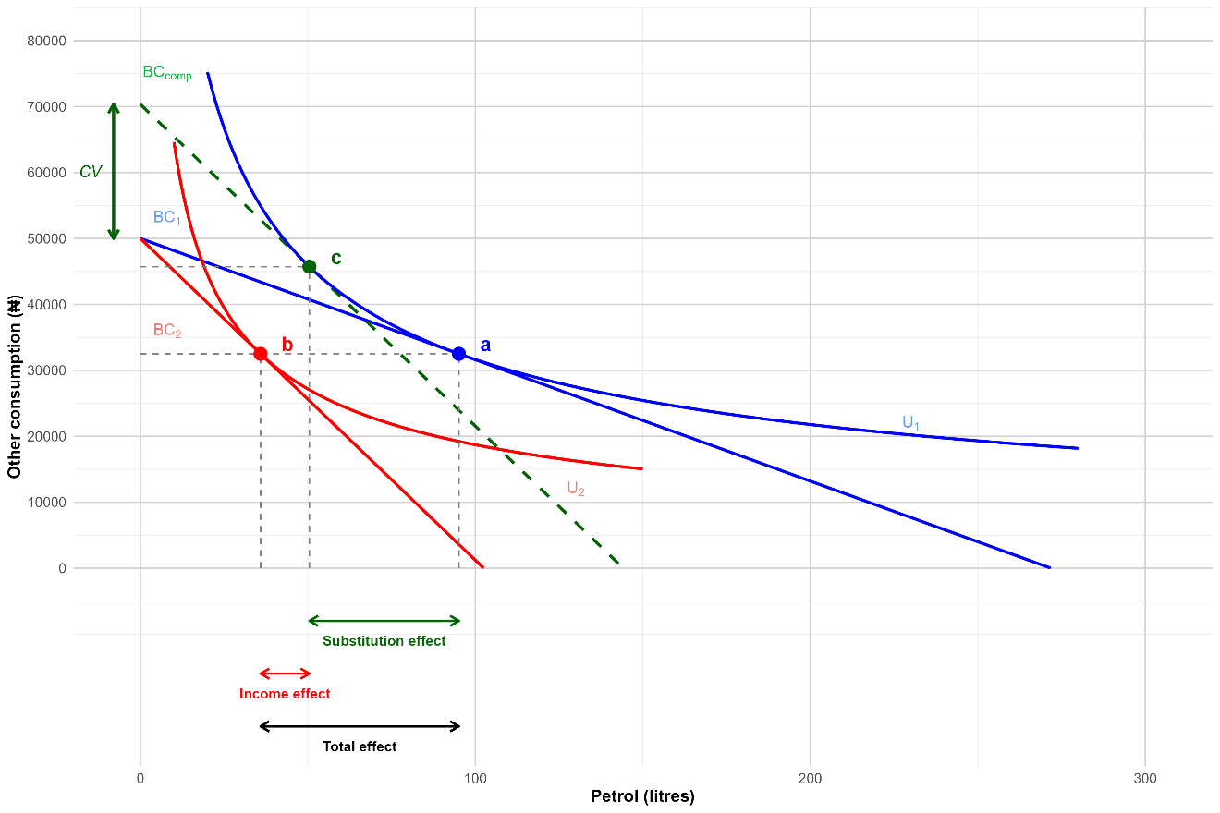

When prices increased on May 31, the budget constraint pivoted inward to BC₂. At the new price of ₦488/liter, the maximum affordable petrol fell to just 102 liters—the household's purchasing power over fuel declined sharply while the y-intercept (representing pure non-fuel spending) remained at ₦50,000. The household's consumption adjusts to point “b” on the lower indifference curve U₂, reducing petrol consumption to approximately 50 liters.
The substitution effect (movement from point “a” to “c”) isolates the pure price response, holding utility constant at U₁. The dashed green line “BC_comp” represents a hypothetical "compensated" budget—one with the new, steeper slope (reflecting the higher petrol price) but shifted outward so the household can still attain their original utility U₁. At point “c”, the household consumes roughly 85 liters of petrol and ₦41,000 of other goods. Even if hypothetically compensated to maintain their original satisfaction level, the household would reduce petrol consumption (from 140 to 85 liters) and increase other consumption, because petrol has become relatively more expensive. Practically, this means switching from private vehicle use to public transport, carpooling, or reducing discretionary trips.
The income effect (movement from “c” to “b”) captures the household becoming poorer in real terms. Without compensation, the household cannot remain on U₁; they must drop to the lower indifference curve U₂. This further reduces petrol consumption (from 85 to 50 liters) and reduces other consumption (from ₦41,000 to ₦25,500). The same ₦50,000 nominal budget now purchases far less overall than before the price shock.
The total effect (movement from “a” to “b”) combines both responses: petrol consumption falls from 140 to 50 liters—a reduction of 90 liters, or about 64%. The vertical distance marked “CV” (compensating variation) on the y-axis shows the additional income—approximately ₦30,000—that would be required to restore the household to its original utility level U₁ at the new prices. This welfare measure quantifies the true burden of the subsidy removal on household well-being.
The substitution and income effects correspond to two key elasticity measures in demand analysis. Uncompensated (Marshallian) own-price elasticity measures the total demand response to a price change, capturing both the substitution effect (movement from "a" to "c") and the income effect (movement from "c" to "b"). This is the elasticity we observe in market data. Compensated (Hicksian) own-price elasticity isolates only the substitution effect by hypothetically compensating the consumer to remain on the original indifference curve. For normal goods, the income effect reinforces the substitution effect when prices rise, so the uncompensated elasticity has larger absolute value than the compensated elasticity. A third measure, budget (expenditure) elasticity, captures how demand responds to changes in total income while holding prices constant.
This graphical analysis demonstrates that price changes affect households through both substitution and income channels. However, to quantify these effects across multiple goods simultaneously—petrol, kerosene, electricity, transport, and other energy sources—and to measure how responses vary across the income distribution, we require a flexible econometric demand system. The Almost Ideal Demand System (AIDS) and its quadratic extension (QUAIDS) provide this framework.

The Almost Ideal Demand System (AIDS)
The Almost Ideal Demand System (AIDS) is a popular tool for demand analysis. It begins with the expenditure function $e\left(p_{t},U_{t}\right)$—where $p_{t}=$ price at time $t$ and $U_{t}=$ utility at time $t$ are considered as factors that determine expenditure (also called consumption). Additionally,
- $ln\left(m_{t}\right)=ln\left(e\left(p_{t},U_{t}\right)\right)=α_{0}+\sum_{i}{α_{i}}ln\left(p_{it}\right)+\frac{1}{2}\sum_{i}{\sum_{j}{γ_{ij}^{*}}}ln\left(p_{it}\right)+U_{t}β_{0}\prod_{i}{p_{it}^{β_{i}}}$
where ${ m}_{t}$is the total expenditure at time $t$, $p_{it}$ is the price of good $i$ at time $t$, $U_{t}$ is the utility at time $t$, and $α,β$ and $γ^{*}$are coefficients of AIDS., Importantly, $β$ is the linear coefficient of AIDS. To skip a few transformations to this formula, the demand equations of the AIDS model become more manageable as an expression of expenditure shares:
(2) $s_{it}\left(p_{t},m_{t}\right)=α_{i}+\sum_{j}{γ_{ij}}ln\left(p_{jt}\right)+β_{i}ln\left(\frac{m_{t}}{P_{t}}\right)$
where $s_{it}=x_{it}\frac{p_{it}}{m_{t}}$ is the expenditure share of good $i$., The formula simply represents the consumed quantity of good $i$ at time $t$ multiplied by a ratio of the price and total expenditure, which gives you a ratio of the total amount of money spent on one good and the total amount spent on all goods. Here is the AIDS model:
$$\left(3\right) w_{i}=α_{i}+\sum_{j=1}^{K}{γ_{ij}lnP_{j}+β_{i}\ln\left\{\frac{m}{a\left(p\right)}\right\}}$$
where $w_{i}$ is the expenditure/budget share for good $i$; $α_{i}$ is the intercept coefficient—the baseline budget share for good $i$ when prices and real expenditure are normalized to 1 (i.e., log = 0); $γ_{ij}$ captures changes in relative prices (between good $i$ and good $j$) and how they affect budget shares; $lnP_{j}$ is the log price of good $j$; $β$ is a linear coefficient that measures how much changes in real expenditure affect budget shares for good $i$; $\ln\left\{\frac{m}{a\left(p\right)}\right\}$represents log real expenditure, and $β$ captures its linear relationship with budget shares. If $β$ is less than zero, the good is a necessity, meaning that as income rises, the share of the budget spent on the good falls. If $β$ is greater than zero, the good is a luxury. This means that as income rises, the share of the budget spent on the good rises.
Table 1.1.1: Measure and Interpretation of Key Terms in AIDS
Term | Measures | Threshold | Interpretation
$$w_{i}$$ | Budget share for good $i$ | N/A | Target variable
$$α_{i}$$ | Baseline budget share for good $i$ | N/A | Budget share of good $i$ when log prices/expenditure = 0
$$γ_{ij}$$ | Cross-price effect between good $i$ and good $j$ | Zero | If > 0, substitutes; if < 0, complements
$$β$$ | Linear unit-level change in expenditure elasticity | Zero | $β<0$ = necessity;  $β > 0$ = luxury

And lastly, to satisfy requirements of utility maximization, AIDS employs three key restrictions. “Adding-up” (∑αᵢ = 1) ensures budget shares sum to one. Homogeneity (∑βᵢ = 0, ∑ⱼγᵢⱼ = 0, ∑λᵢ = 0) ensures demand is homogeneous of degree zero in prices and income—proportional changes in all prices and income leave quantities unchanged. Slutsky symmetry (γᵢⱼ = γⱼᵢ) ensures cross-price effects are symmetric, reflecting that the order of price changes does not affect consumption patterns.

$$(4) \sum_{i=1}^{k}{α_{i}}=1,\sum_{i=1}^{k}{β_{i}}=0,\sum_{j=1}^{k}{γ_{ij}}=0,\sum_{i=1}^{k}{λ_{i}}=0,γ_{ij}=γ_{ji}$$
Okereke et al. build on this model to analyze the welfare impacts of fuel subsidy removal in Nigeria.

Chapter 2: Data, Methods and Results

The primary model used by Okereke et al. (and hence this study) is the Quadratic Almost Ideal Demand System (QUAIDS). It is a demand system of rank three, which means it has three linearly independent vectors (i.e., $γ$, $β$, and $λ$), the maximum amount a price function can have. This makes the demand system more flexible and more accurate in estimating non-linear Engel curves. Unlike AIDS, QUAIDS has a quadratic term ( $\frac{λ_{i}}{b\left(p\right)}{\left[\ln\left\{\frac{m}{a\left(p\right)}\right\}\right]}^{2}$) in its budget share equation that allows goods to be classified as necessities or luxuries at different levels of expenditure:
$$\left(5\right) w_{i}=α_{i}+\sum_{j=1}^{K}{γ_{ij}lnP_{j}+β_{i}\ln\left\{\frac{m}{a\left(p\right)}\right\}}+\frac{λ_{i}}{b\left(p\right)}{\left[\ln\left\{\frac{m}{a\left(p\right)}\right\}\right]}^{2}$$
where $a\left(p\right)$ and $b\left(p\right)$ are price aggregator functions (derived from the underlying cost function). The term $λ_{i}$ is the quadratic expenditure coefficient, which adjusts alongside (log) expenditure. This captures the second order (nonlinear) expenditure effects that linear models like AIDS ignore.,, By capturing changing price elasticity at varying levels of expenditure, QUAIDS better approximates the non-linear Engel curve in a way that makes it superior to AIDS for demand analysis.
The specific version of QUAIDS in Okereke et al. (2024) has additional terms that account for socio-demographics: household’s location, gender of the household, ownership of a motorbike, and the size of the household:
$$\left(6\right) w_{i}=α_{i}+\sum_{j=1}^{K}{γ_{ij}lnP_{j}+β_{i}\ln\left\{\frac{m}{a\left(p\right)}\right\}}+\frac{λ_{i}}{b\left(p\right)}{\left[\ln\left\{\frac{m}{a\left(p\right)}\right\}\right]}^{2}+\sum_{k}^{n}{ϕ_{ik} }z_{k}+δ_{i}$$
where $\frac{λ_{i}}{b\left(p\right)}{\left[\ln\left\{\frac{m}{a\left(p\right)}\right\}\right]}^{2}$is the quadratic term, $z_{k}$ denotes the $K$ socio-demographic variable, and $ϕ$ denotes the shift of the budget share due to the household characteristic. Also, $i=1, ... , N$ represents each household and $δ_{i}$ is the independent and identically distributed error term with covariance matrix $\sum{k}$. Okereke et al. (2024) used Equation (6) to estimate the budget shares, as well as the expenditure, own-price and cross-price elasticities, of petrol, electricity, transport, kerosene, and other household energy sources (i.e., wood, charcoal, diesel, and additional fuels). The estimated elasticities were then used to assess the welfare consequences of fuel price increases, which were measured as CV, or compensating variation. CV measures the total monetary transfer necessary to bring the consumer back to their original utility level after a price change and is taken as a percentage of their original total expenditure. The following model represents CV in relation to changes from $p^{a}$ to $p^{b}$ of fuel:$$\left(7\right) CV=e\left(p^{a},v^{a}\right)-e\left(p^{b},v^{a}\right)\int_{p^{a}}^{p^{b}}{h\left(p,v^{a}\right).dp }$$
where $v$ and $e$ are generic indirect utility and expenditure functions. To better show which household groups are more disadvantaged by the fuel price changes, CV is disaggregated by household location and income group. And lastly, Okereke et al. (2024) analyzed the effect of a lump-sum transfer of savings from the removal of the fuel subsidy to three different lower-income groups: two under the national poverty line (upper and lower bounds), and one comprising households in the bottom 40% of the income distribution.

Data Sources
The major data source used for Okereke et al.’s study are General Household Surveys conducted under the Living Standards Measurement Study (LSMS). The first LSMS was conducted in Côte d’Ivoire in 1985, and it served as the model for future studies. Today, it aims to “strengthen the availability, quality, relevance, and timeliness of household surveys implemented in low- and middle-income countries, for improved policymaking and better lives.” The typical LSMS survey has three separate questionnaires: a household, community and price questionnaire.
Nigeria’s first General Household Survey (GHS) was conducted on two visits between 2010 and 2011. It was a cross-sectional survey of 22,000 households that has since been conducted annually across the country (also known as the Nigeria Living Standards Survey or the NLSS). The subject of Okereke et al.’s paper is the GHS-Panel, which is a sub-sample of the GHS. So far it has been conducted in five waves: 2010/11, 2012/2013, 2015/2016, 2018/19 and 2023/24. The GHS-Panel is a nationally and zonally representative survey of 5,000 households from the GHS that collects “additional data on multiple agricultural activities and on household consumption” to highlight connections between the agriculture sector and household welfare. This suggests that the GHS-Panel is ideal for empirically assessing the welfare impacts of the 2023 fuel subsidy removal.
Okereke et al. used a pooled panel comprised of Nigerian GHS/Panels conducted from 2012/2013, 2015/2016, and 2018/2019. I use the 2023/24 data to examine the incidence of fuel subsidies in Nigeria.

Replication Framework (Waves 2-4)
Due to the unavailability of the original Stata code (and of Stata), the econometric framework was reconstructed in R using relevant guides and foundational papers on the Almost Ideal Demand System (AIDS),, as well as a study using the QUAIDS model to analyze South African household data., These efforts were supplemented using generative AI tools for syntax generation, which I manually verified against the theoretical derivations outlined by Henningsen (n.d.) and debugged as needed. For the replication, waves 2-4 (2012/2013, 2015/2016, and 2018/2019) of the Nigerian GHS-Panels were used.
Table 2.2.1 compares my replication results (Waves 2-4, N=11,646) with Okereke et al. (2024)'s published estimates (Waves 2-4, N=13,496). The "Pct Diff" column reports percentage differences calculated as |(Replication - Okereke)/Okereke| × 100, while "Match" indicates: ✓ (within 10%), ~ (10-15%), or ✗ (>15%). I achieve a partial replication: sample characteristics and own-price elasticities match closely, but QUAIDS structural coefficients differ substantially. Critically, the compensated and uncompensated own-price elasticities—which directly determine welfare impacts from subsidy removal—replicate within 5%, validating the demand response mechanism for the Wave 5 extension.
Table 2.2.1: Replication Comparison—My Results vs. Okereke et al. (2024)
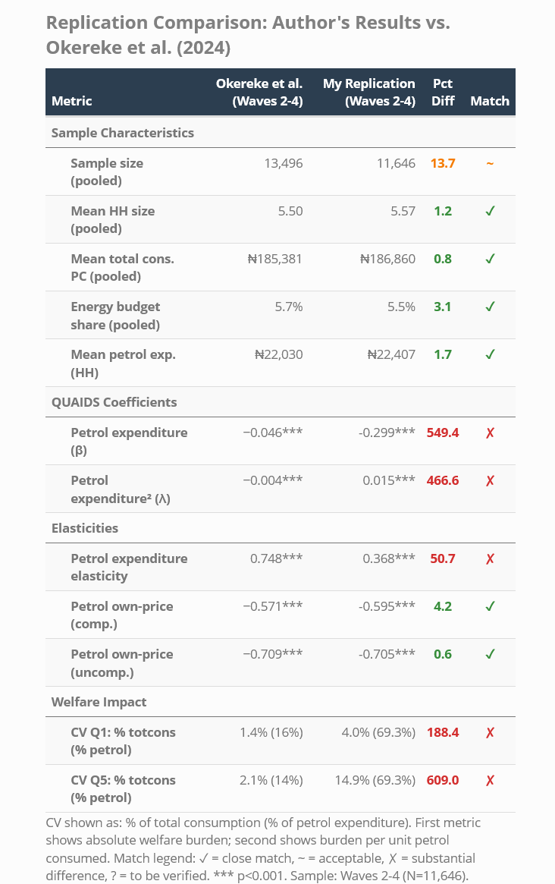
Match Legend: ✓ = Close match (< 10% difference or exact) ~ = Acceptable match (10-15% difference) ✗ = Poor match (> 15% difference)
Notes: Pooled values calculated across all three waves (2012/13 to 2018/19). Sample size differences (13,496 vs 11,646) reflect stricter filtering in replication. By-wave statistics show closer agreement than pooled means. Okereke targets are from Table 1 of published paper.
Sample characteristics align closely on most metrics: household size (5.57 vs 5.50, 1.2% difference), per capita consumption (₦186,860 vs ₦185,381, 0.8%), energy budget share (5.5% vs 5.7%, 3.1%), and mean petrol expenditure (₦22,407 vs ₦22,030, 1.7%). Sample size differs by 13.7% (11,646 vs 13,496), reflecting stricter filtering to exclude households with inconsistent energy reporting.
The linear expenditure coefficient β differs by 549% (-0.299*** vs -0.046***), while the quadratic coefficient λ shows opposite signs and 467% difference (0.015*** vs -0.004***). To illustrate β's practical meaning: a household doubling total expenditure from ₦50,000 to ₦100,000 (a 0.69 increase in log expenditure) would decrease their petrol budget share by 0.21 percentage points (-0.299 × 0.69 ≈ -0.21), holding prices constant. The quadratic coefficient λ captures the non-linearity of this relationship: as expenditure increases further, the marginal effect of income on petrol's budget share itself changes, allowing goods to transition between necessity and luxury status at different expenditure levels. Both remain highly significant (p<0.001), but the magnitude and sign differences suggest divergent approaches to Stone price index construction, demographic scaling, or constraint imposition (adding-up, homogeneity, symmetry).
Elasticities show mixed success. Expenditure elasticity differs by 51% (0.368*** vs 0.748***), indicating petrol is less income-responsive in my model. However, own-price elasticities replicate remarkably well: compensated differs by only 4.2% (-0.595*** vs -0.571***) and uncompensated by 0.6% (-0.705*** vs -0.709***). These close matches validate that my demand system correctly captures household price responses—the core behavioral mechanism determining welfare impacts.
Welfare estimates diverge substantially, likely due to methodological differences. Q1 compensating variation is 188% higher (4.0% vs 1.4% of total consumption), while Q5 shows 609% difference (14.9% vs 2.1%). When normalized by petrol expenditure, both quintiles show 69.3% in my replication versus Okereke's 16% (Q1) and 14% (Q5). These gaps reflect: (1) my second-order QUAIDS approximation versus their unspecified method, (2) different price shock treatments, and (3) compositional differences from stricter sample filtering. Importantly, the qualitative pattern holds in both studies: welfare losses increase with income when measured as percentage of total consumption, suggesting that subsidies disproportionately benefit wealthier households.

Extension Framework (Wave 5)
Due to the unavailability of official Wave 5 consumption aggregate data, I constructed a proxy measure following standard LSMS methodology: summing annualized expenditures on food (including own-production), meals away from home, non-food items, education, health, and housing. This approach necessarily omits spatial and temporal price deflators, which are typically applied during official aggregate construction and would be difficult to construct independently.
Table 2.3.1 cites and interprets proxy and official estimates for the wave 4 consumption aggregate, their absolute difference, their mean difference percentage, the correlation between the proxy and official estimates, and the root mean square error. The proxy overestimates mean per capita consumption by 48% (₦396,228 vs. ₦221,123), with a Pearson correlation of 0.513 and large RMSE (₦1,039,000) driven by wealthy households. This systematic overestimation—reflecting the absence of spatial and temporal price deflators—demonstrates the proxy cannot accurately measure absolute consumption levels. However, distributional incidence analysis requires only that the proxy correctly rank households across income groups, not that it measures absolute expenditure precisely.
Table 2.3.1: Overall Fit of Wave 4 Proxy Consumption Aggregate
Metric | Value | Interpretation
Proxy mean | ₦396,228 | Constructed proxy says average household consumes this much per capita
Official mean | ₦221,123 | Official aggregate says it's this much
Difference | +₦175,105 (+79%) | Proxy overestimates official figures by nearly 2x
Mean diff % | 48% | On average, the proxy is 48% higher than official
Correlation | 0.513 | Moderate linear relationship (not terrible, not great)
RMSE (root mean square error) | ₦1,038,998 | Large prediction errors (driven by rich households)

The validation statistics in Table 2.3.2 indicate that while the proxy overestimates absolute consumption levels, it preserves distributional patterns adequately for incidence analysis. The Spearman rank correlation of 0.81 exceeds benchmarks from experimental studies of consumption measurement: Beegle et al. (2012) find that abbreviated consumption modules achieve correlations of 0.60-0.75 with detailed diary benchmarks, and conclude such proxies are "useful for identifying the poor and analyzing distributional impacts" despite absolute level imprecision. The proxy aggregate correctly classifies 57.6% of households into their income quintile—nearly three times the 20% expected by random chance. This classification accuracy is comparable to proxy means tests used in World Bank poverty targeting programs, which achieve ~55% quintile accuracy and are deemed "sufficient for identifying groups at differential welfare levels."
Table 2.3.2: Distributional Match Between Official and Proxy Wave 4 Consumption Aggregate
Metric | Value | Interpretation | Academic Standard
Spearman ρ | 0.81 | Strong rank preservation | >0.7 = acceptable
Quintile accuracy | 57.6% | More than half correctly classified | >50% = better than random (20%)
Implication | — | Constructed proxy preserves relative ordering of households | Suitable for incidence analysis (based on published standards)

Results
Figure 2.4.1 compares energy access rates before (Wave 4, 2018/19) and after (Wave 5, 2023/24) subsidy removal. The most dramatic change is kerosene access, which collapsed from 55.2% to 22.5%—a 59% decline—suggesting many households were priced out of this traditionally affordable fuel. In contrast, petrol access increased modestly (48.2% to 56.6%) and electricity rose slightly (41.5% to 45.6%), while diesel remained negligible (<1%) and other energy sources stayed stable (~45%). These rates use weighted proportions of households with positive expenditure, making them robust to Wave 5's consumption measurement limitations.
Figure 2.4.1: Energy Access Rates by Fuel Type
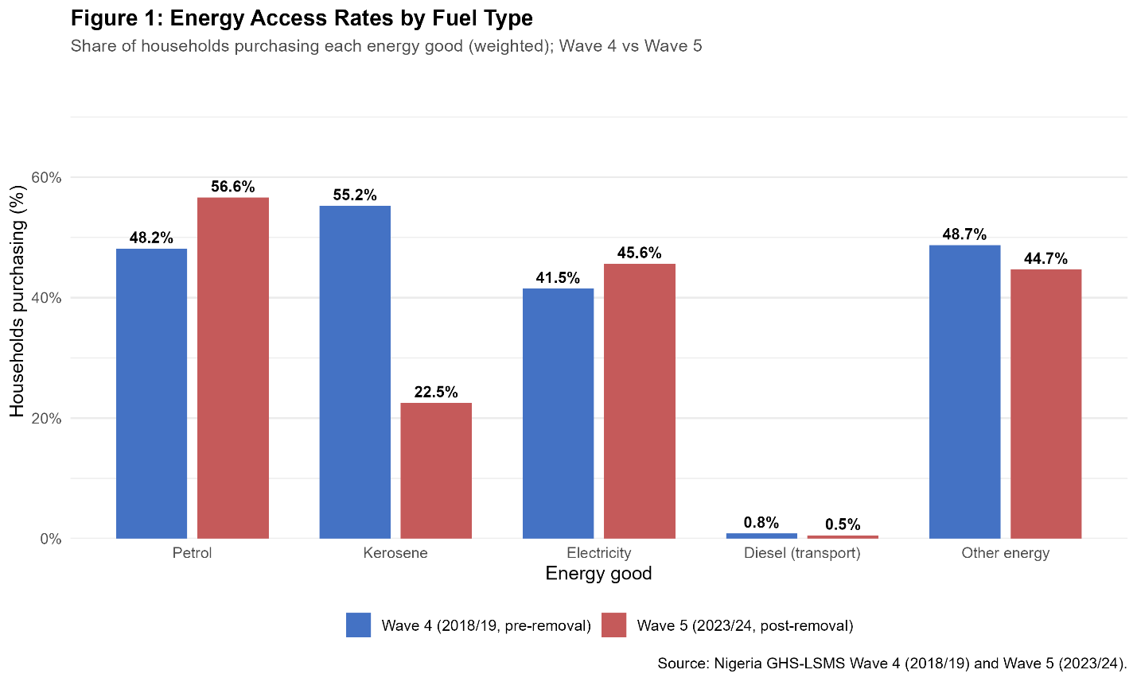
Figure 2.4.2 displays energy budget composition by fuel type across income quintiles for Waves 4 and 5. Kerosene access collapsed from 55.2% to 22.5% of households overall, while among poor households that remained in energy markets, kerosene's share of energy budgets stayed persistently high (~52% in both waves), indicating continued dependence on this fuel. Meanwhile, kerosene nearly disappeared from wealthy households' energy portfolios (Q5: 8% in Wave 4 to 3% in Wave 5).
Figure 2.4.2: Within Energy Budget Shares by Quintile
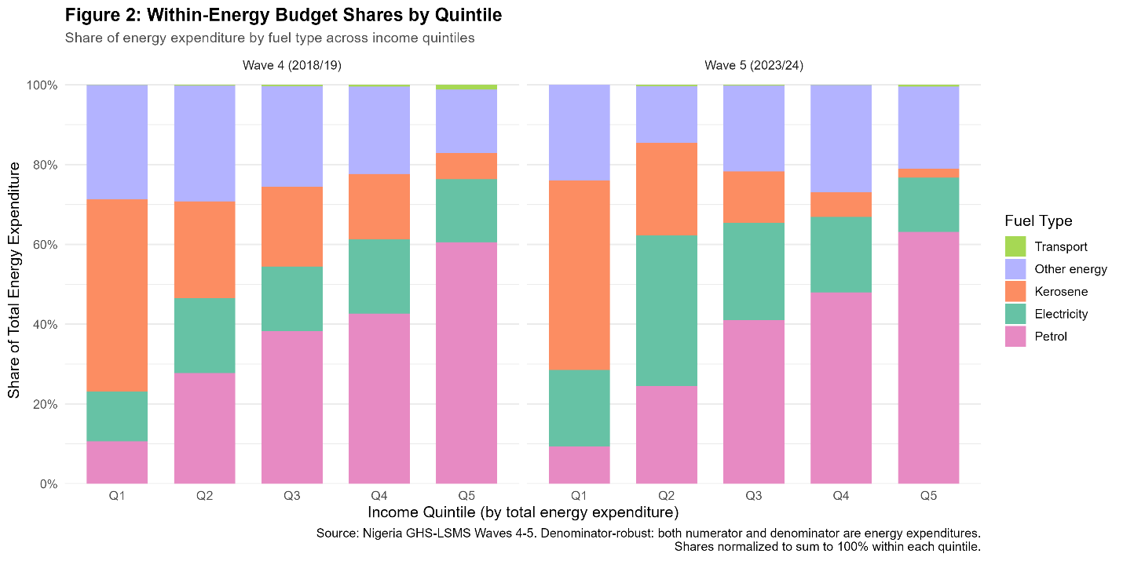
Figure 2.4.3 presents concentration curves for five energy goods, plotting cumulative expenditure shares against population shares ranked by total consumption. Curves below the 45° equality line indicate regressive (pro-rich) distribution. Diesel exhibits the most extreme regressivity: the bottom 50% of households consume less than 10% of total diesel expenditure, while the top 10% consume 55%. Petrol shows substantial but less extreme regressivity (bottom 50% consume 25%, top 10% capture 35%). Kerosene displays the most equitable distribution, with its curve closest to the diagonal. This analysis uses Wave 4's validated NBS/WBG consumption aggregate, ensuring full reliability and comparability to published studies.
Figure 2.4.3: Concentration Curves for Energy Goods (Wave 4)
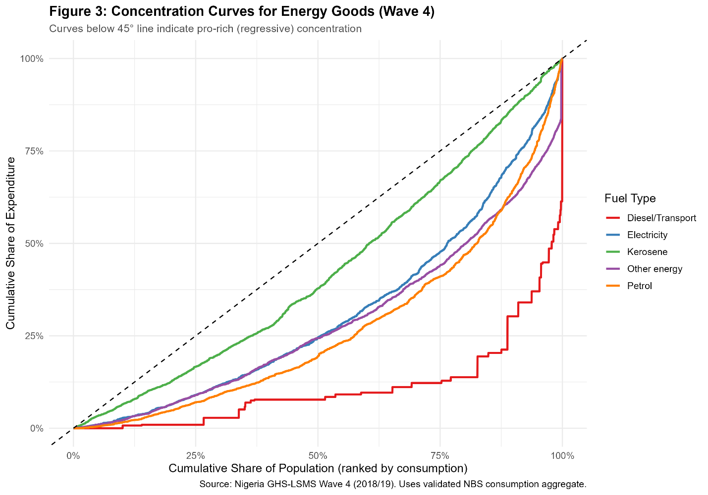
Figure 2.4.4 displays energy expenditure as a percentage of total household consumption across income deciles for Wave 4 (2018/19). Total energy spending exhibits a clear positive income gradient, rising from 4.5% of consumption in the poorest decile to 9% in the richest. Petrol expenditure drives this pattern, increasing from 2% (bottom decile) to 4.5% (top decile), while kerosene remains flat (~1%) and “other energy” (e.g., charcoal, firewood) declines as a share of consumption. Using Wave 4's validated NBS/WBG aggregate, this pattern demonstrates that fuel subsidies delivered larger benefits to wealthier households in both absolute and proportional terms.
Figure 2.4.4: Expenditure Shares by Income Decile (Wave 4)
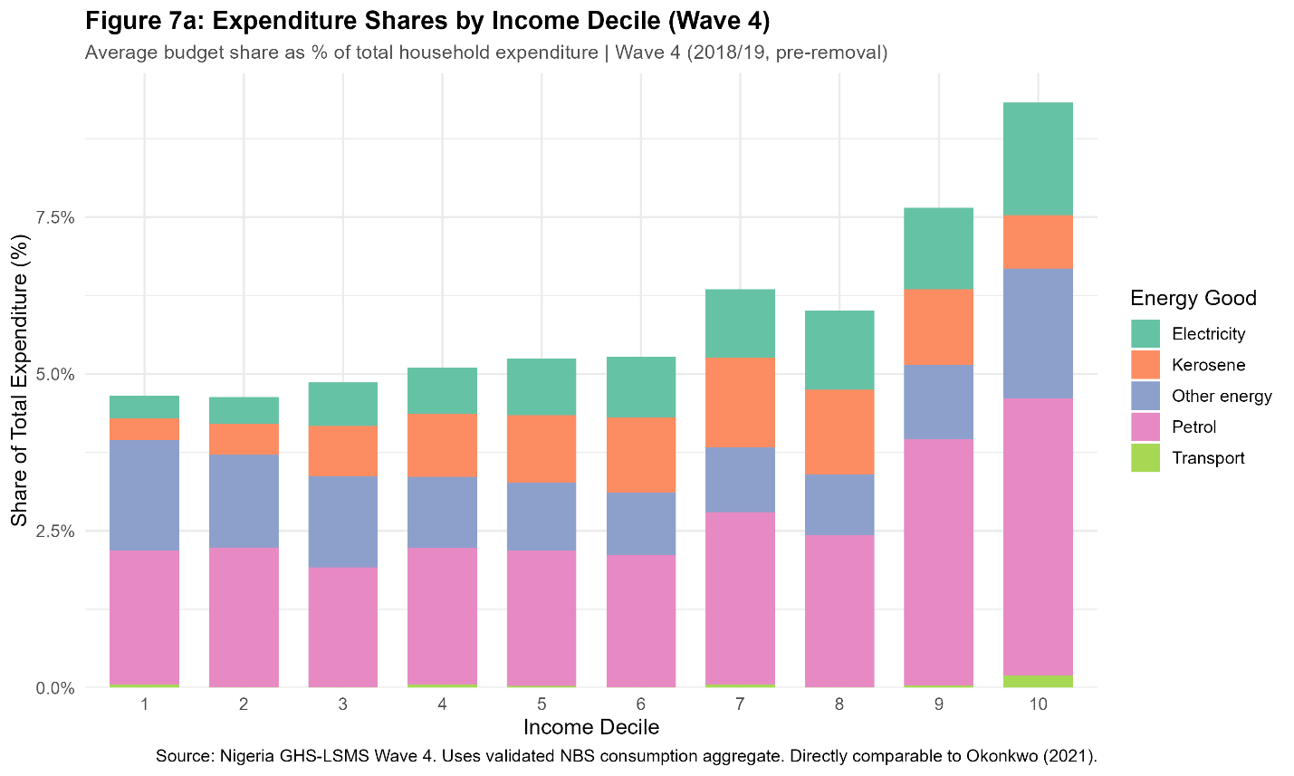

Discussion
I achieve a partial replication of Okereke et al. (2024) that I extend to analyze the welfare impacts of Nigeria's May 2023 fuel subsidy removal. My analysis reveals two major findings.
First, fuel subsidies are highly regressive. The poorest quintile allocates roughly 10% of energy spending to petrol versus the richest quintile's 60%, a pattern that persists even after subsidy removal. Concentration curves show this stark inequality: the bottom 50% of households consume just 25% of total petrol expenditure, while the top 10% capture 35%. Energy spending as a share of total consumption rises from 4.5% in the poorest decile to over 9% in the richest, driven entirely by petrol's gradient from 2% to 4.5%. This concentration aligns with broader evidence that fuel subsidies in developing countries disproportionately benefit wealthier households. This regressivity manifests not only in baseline consumption patterns but also in behavioral responses to subsidy removal.
Second, the May 2023 fuel subsidy removal triggered dramatic changes in energy market participation with asymmetric patterns across the income distribution. Kerosene access collapsed from 55.2% to 22.5%—a 59% decline. Given that Wave 4 data shows kerosene concentrated among poor households (comprising ~52% of Q1 energy budgets), this collapse suggests many poor households were priced out of formal energy markets. Meanwhile, overall petrol access rose from 48.2% to 56.6%, with petrol's share of energy budgets remaining concentrated among wealthy households (Q5: 60% in Wave 4, 63% in Wave 5). This asymmetric pattern—kerosene collapse alongside petrol resilience—indicates that subsidy removal imposed unequal distributional burdens, with the poorest households experiencing the most severe disruptions to energy access.
These findings directly address the study's central question: who bears the burden of fuel subsidy removal? While all households faced price increases, the distributional impacts are profoundly unequal. Wealthier households capture the majority of subsidy benefits (60% of petrol spending within energy budgets), experience welfare losses primarily through reduced purchasing power, without needing to exit petrol markets or substitute to inferior fuels. Poor households, in contrast, experience forced substitution toward inferior energy sources. The evidence consistently demonstrates that Nigeria's fuel subsidy regime functions as a regressive transfer to wealthier households.

Replication Challenges and Methodological Differences
My replication reveals a measurement puzzle regarding welfare loss magnitudes. Okereke et al. (2024) report that Q1 households require 16% of their petrol expenditure as compensation versus Q5's 14%—evidence that poor households face higher per-unit welfare losses. In my replication, both quintiles show identical 69.3% burdens when measured against petrol expenditure, but Q5 households require 14.9% of total consumption as compensation versus Q1's 4.0%—seemingly suggesting wealthier households are hurt more. This apparent discrepancy reflects methodological choices rather than substantive disagreement about subsidy incidence. Three factors explain the divergence:
First, different CV approximation methods. I use a second-order QUAIDS approximation that captures non-linear welfare effects through the quadratic expenditure term, while Okereke et al. do not specify their formula. Second-order approximations typically yield larger magnitude estimates—hence my 69.3% versus their 14-16%—because they account for diminishing marginal utility and non-linear Engel curves that first-order approximations ignore.
Second, normalization choices obscure comparability. When CV is expressed as a percentage of petrol expenditure, it measures per-unit burden (how trapped households are in petrol consumption due to limited substitution options). When expressed as percentage of total consumption, it measures absolute welfare burden (overall standard of living impact). The poorest quintile spent only 10% of their energy budget on petrol in Wave 4, while the richest spends 60%. Even with identical per-unit burdens (69.3%), Q5's higher petrol spending generates a larger impact as a share of total consumption. This is not a contradiction. Rather, it reflects the fact that wealthier households consume more petrol in absolute terms, so removing subsidies costs them more in naira, even if poor households face larger proportional welfare losses relative to their petrol consumption.
Third, Wave 5 consumption measurement limitations affect absolute magnitudes but not qualitative patterns. Because the official Wave 5 consumption aggregate has not been released, my estimates use a partial consumption measure that likely inflates CV/consumption ratios. This affects precise welfare loss estimates but not the distributional finding that petrol consumption is concentrated among wealthier households. Importantly, both my replication and Okereke et al. reach the same substantive conclusion: fuel subsidies disproportionately benefit higher-income households in absolute terms, even as poor households may face larger per-unit burdens.

Scope Limitation: Cash Transfer Analysis
Okereke et al. (2024) extend their analysis to assess whether lump-sum cash transfers—financed by recycling subsidy savings—could compensate targeted groups (bottom 40%, poverty line thresholds) for welfare losses. However, they do not provide sufficient methodological detail to replicate this component. Specifically, the paper does not report: (1) baseline government subsidy expenditure, (2) fiscal calculations of subsidy savings under the simulated price shock, or (3) the mechanism by which transfers are incorporated into compensating variation estimates. Consequently, I cannot estimate the compensating transfer amounts for Wave 5 households.
This limitation may be less consequential than it appears. As Chapter 3 shows, Nigeria's actual implementation of cash transfers post-subsidy removal has fallen far short of the targeting precision and coverage breadth assumed in policy simulations. The gap between theoretical mitigation strategies and political economy realities suggests that understanding who bears the burden (this chapter's focus) is more policy-relevant than calculating precise transfer amounts under idealized implementation assumptions.

Limitations
Beyond this scope limitation, this study's primary limitation is Wave 5's proxy consumption aggregate, which overestimates absolute consumption levels by 48% due to missing spatial and temporal price deflators. Consequently, precise welfare loss magnitudes and poverty impact calculations await official Wave 5 data release expected in late 2026. However, this limitation does not undermine the core distributional findings. The proxy preserves rank ordering with strong accuracy (Spearman ρ = 0.81, quintile classification 57.6%), exceeding benchmarks from experimental consumption measurement studies. As Beegle et al. (2012) demonstrate experimentally, consumption proxies with correlations above 0.60 reliably identify relative household welfare for poverty analysis, even when absolute levels diverge from gold-standard measures. My proxy (ρ = 0.81) exceeds this threshold.
Moreover, the key results rely on denominator-robust metrics that do not depend on total consumption measurement: energy access rates (proportion with positive expenditure), within-energy budget shares (energy/energy ratios), and concentration curves using Wave 4's validated aggregate. These measures reliably identify which income groups bear disproportionate welfare impacts—the study's central objective. Future research should revisit precise welfare magnitudes once official data are available and investigate the health and time-use consequences of forced kerosene substitution, including heterogeneous impacts across household types, gender, and geographic location.

Conclusion
Despite methodological differences producing varying welfare loss magnitudes, the qualitative finding of subsidy regressivity is robust across specifications, waves, and measurement approaches. Two independent lines of evidence converge: concentration of petrol spending among high-income quintiles and asymmetric behavioral responses to price shocks. Nigeria's 2023 fuel subsidy removal eliminated a regressive fiscal transfer but imposed unequal distributional effects on poor households through forced energy substitution. These distributional consequences have direct implications for policy design, explored in Chapter 3.

Chapter 3: Policy Recommendations

Chapter 2 established two findings. First, Nigeria’s fuel subsidies were regressive: petrol consumption was heavily concentrated among high-income households, with the richest quintile allocating roughly 60% of energy spending to petrol vs. 10% for the poorest. Second, subsidy removal triggered asymmetric behavioral responses, including a 59% collapse in kerosene access, which contributed to severe disruptions in energy access among the poorest households. This chapter turns to the policy implications: given who bore the burden, what interventions could redress the welfare losses?
Evaluating compensatory policies requires acknowledging Nigeria's pre-existing poverty crisis. Even before the May 2023 subsidy removal, 39.7% of Nigerians experienced multidimensional poverty—lacking primary education, clean water, sanitation, and electricity access—while 40% survived on roughly $1/day. This context has two implications for policy design. First, subsidy removal exacerbated already-dire conditions for the poorest households, who lacked financial buffers to absorb price shocks. Second, compensatory policies must prioritize the bottom income quintiles identified in Chapter 2, as these households face compounding deprivations beyond fuel price increases.
Chapter 2 demonstrated that fuel subsidy removal imposed asymmetric welfare costs: poor households lost access to modern fuels (kerosene access collapsed 59%), while wealthy households captured most pre-reform subsidy benefits (60% of petrol spending). Three compensatory policies could address these distributional impacts: conditional cash transfers, transportation infrastructure investment, and refinery rehabilitation. Each targets different populations, operates on different timelines, and faces distinct implementation challenges.

Policy #1: Conditional Cash Transfers
Conditional cash transfers (CCTs) represent the most direct mechanism to restore purchasing power lost from fuel price increases. Unlike unconditional payments, CCTs tie cash receipts to behaviors—school enrollment, health clinic visits, nutritional monitoring—that address both immediate consumption needs and long-term poverty traps. This dual function makes CCTs particularly relevant for Nigeria's post-subsidy context, where poor households reduced modern fuel consumption (Chapter 2) and face competing pressures on scarce budgets.
A landmark CCT program is Oportunidades, which boosted school enrollment rates, educational level, nutrition and health prevention in Mexico. Young male beneficiaries of Oportunidades have nearly ten additional months of schooling, while young women beneficiaries have nearly eight additional months of schooling. While Nigeria's context differs—larger population (~200 million vs. ~100 million), weaker administrative capacity, higher corruption—Mexico's experience suggests well-targeted CCTs can compensate for energy subsidy removal while building human capital.
”In Care of the People” (COPE) was Nigeria’s first nationwide government-led CCT program. It was launched in 2007 during President Umaru Musa Yar’Adua’s administration across 12 of Nigeria’s 36 federated states. The COPE CCT was intended to combat intergenerational poverty and reduce socio-economic barriers by boosting human capital. Eligible households need at least one child of primary or junior secondary school age. To become beneficiaries, children in the household receiving basic education need to have at least 80% school attendance, and household members must participate in all free government sponsored health care (immunization) programs., Special preference was given to households with poor female household heads; elderly and physically challenged persons; and, vesicovaginal fistula (VVF) patients and HIV/AIDS patients.
Beneficiaries of the COPE CCT received a monthly Basic Income Guarantee (BIG), followed by a lump sum “poverty reduction accelerator investment (PRAI)”. The BIG ranged from $10 (NGN1500) to $30 (NGN4500) based on the number of children in the household, and an additional $50 per month was withheld as mandatory savings, which was distributed as the PRAI (up to $560) to the head of the household. Selected households can only enter COPE for a year. After they leave the program, a PRAI payment of NGN84,000 is paid to each household or used to “purchase equipment to help them set up a business or trade”. But unlike other CCTs in various African and Latin American countries, the PRAI payment assumes that the income generated by the business or trade will be sufficient for breaking intergenerational poverty. Thus, each household is expected to provide a member who would be trained or supported by the government with the PRAI money in a business or trade of their choice.
The COPE CCT had a variety of challenges, primarily its small term limit and coverage. Unlike landmark CCTs like Oportunidades in Mexico, Nigerian households can only participate in COPE for one year, “without possibility of extension.” It may be relevant to mention how difficult it is to assess the effectiveness of CTPs, as they often involve various strategies and modes of execution. Moreover, CTPs are given in a “diverse range of settings to a diverse group of beneficiaries”. In that scenario, food security is a promising measure of an effective CTP as it is the most researched nutrition-related benefit of cash transfers. But in the case where less than 0.1% of the poor population received cash transfers, which were supported for only one year and not tracked afterward for signs of socio-economic progress, the COPE program failed to reach its intended goals.
Apart from CCT programs, the Nigerian government uses two other major protection policies: subsidized maternal and child health care (MCH) provisions and the Community-based Health Insurance Scheme (CBHIS). Other social assistance programs are run in an “ad hoc manner… by government ministries, departments and agencies (MDAs) at [the] state level.” This narrow and uncoordinated approach to social protection presents further challenges in the government’s current efforts to alleviate poverty in Nigeria.
Unfortunately, the COPE’s successor, the “Renewed Hope Conditional Cash Transfer” program, shares its predecessor’s lack of coverage. Almost 5 months after removing fuel subsidies, President Tinubu announced the CCT program that would ultimately replace COPE on October 17, 2023. He stated that the government will partner with the World Bank Group and other development partners to carry out the “Renewed Hope” program. The CCT program was intended to conduct “direct, time bound transfers of NGN 25,000” to roughly 15 million households (over 60 million Nigerians)., This is less than 25% of the Nigerian population (roughly 228 million as of 2023), and less than half of Nigeria’s impoverished population. As of May 2025, only 5.6 million households (~20 million Nigerians) received at least one portion of the total NGN 25,000. So, the “Renewed Hope Conditional Cash Transfer” program set unsatisfactory goals for eradicating poverty that the Nigerian government failed to meet in the span of 19 months.
Revamping the 2023 conditional cash program is one way to support low-income households post-subsidy removal. Such a program would need to define its population as the bottom 40% of households to ensure that it adequately targets all economically vulnerable households post-subsidy removal. Moreover, such a CCT needs to estimate the total sum of naira required to offset the negative welfare impacts of the fuel price increases and restore consumers to their original utility. Additionally, more investment is needed in the National Registry. This is because low-income households need to register with the National Registry to ensure they receive timely and consecutive payments from the government. Lastly, between 2019 and 2024, 42 million more people entered poverty, increasing the poverty rate from 40 to 47%. So, more money is needed to target these recently impoverished people. But apart from conditional cash transfers, the Nigerian government could consider another policy that quickly addresses the distributional welfare impacts of the fuel subsidy removal.

Policy #2: Transportation Subsidies Supported by Infrastructure Investment
Transportation subsidies are often used to make urban transportation more affordable and accessible to low-income individuals. There are case studies of transportation subsidies in “developed” countries like the U.K and France, and “developing” countries like Argentina and Colombia. Particularly in Latin America, which has many “developing” countries, studies have found that transportation subsidies increase ridership among lower-income individuals. While transportation subsidies are not widely used in Nigeria, they would allow Nigerians to use transportation more frequently—almost as frequently as before the fuel subsidy removal. This seems especially plausible as price increases in transportation was found to increase operation costs for informal operations, which led to increased fares, reduced accessibility and declining real incomes in Sokoto State. Moreover, another study found that the increase in the price of fuel was significantly correlated with the increasing the price of transportation in Benue State. However, Nigeria and much of Sub-Saharan Africa’s transportation architecture is largely incomplete, heavily leaned toward rail development, and largely unprepared for urbanization.
Unlike some Latin-American countries, informal transportation dominates major urban cities in Nigeria. And until 2008, the nation’s largest megacity at the time was the only one in the world without any organized public transportation system. In Lagos, Nigerians relied on a large fleet of 75,000 minibuses (danfo), along with smaller numbers of midi-buses (molue), shared taxis (kabu-kabu) and motorcycle taxis (okada) to travel long and short distances in the absence of formalized, government-funded transit options. The Bus Rapid Transit system was launched in 2008 to meet that gap, and was a bus-based mass transit system providing Lagos commuters with a “clean, affordable and reliable” means of transportation. It is the first of its kind in sub-Saharan Africa and builds on lessons from successful public transit systems in countries mentioned previously like Colombia and Brazil, while adapting to continental needs. According to a representative of the Sub-Saharan Africa Transport Policy Program, over 200,000 commuters have used the BRT-Lite daily since it was implemented. Additionally, passengers paid 30% less on average for fares, passengers were less exposed to theft on public transport, and passengers enjoyed a 40% reduction in commute time as well as a 35% reduction in wait time. And when surveyed, 31% of commuters only relied on the BRT for transportation—a remarkable figure in a city where there used to be no public transit system. However, the BRT-Lite has struggled to meet the transportation needs of Nigerians in Lagos as its population grew over time.
On February 5, 2025, the Managing Director and CEO of Lagos Bus Services Ltd, Idowu Oguntona addressed Lagos commuters about long wait times at BRT-Lite terminals. Oguntona said that “[t]he service is dealing with the growing population in Lagos, which has resulted in increased demand,” and that “[t]here are also plans by the Lagos State Government to increase the number of buses we have to meet the growing demand.” However, the issue of long wait times and low number of buses still appears to remain unresolved. As recent as March of 2026, Lagos commuters were found waiting at least 2 hours at the Ikorodu BRT terminal. She was also harassed by other passengers, including a BRT-Lite employee for speaking out about the long lines and extreme bus shortages. Although the Lagos State Government reduced bus fares by 25% in 2023, the LMATA increased the cost of BRT-Lite services by 18% almost 2 years later, and all other modes of transport (as implicated by the replicated study) have become more expensive after the fuel subsidy removal. This worsens the living conditions for the average Nigerian.
Policymakers could consider making Nigeria’s transportation system’s services more efficient while lowering costs. Much of the push for deregulation and privatization comes from this fiscal imperative. Introducing competition can increase operational efficiency so fares can be kept lower without subsidies. If it is not possible to achieve full cost recovery, then subsidies should be narrowly focused on the established goals and delivered through competitively awarded service contracts. The reason for this is like the reason why petroleum subsidies alone are inadequate in resolving the welfare impacts of the fuel subsidy removal: the pre-reform level of utility was drastically low. Weak transportation infrastructure likely exacerbated the pre-2023 poverty levels further with traffic congestion, air/noise pollution, and long waiting times. Improving the efficiency of transportation systems in Nigeria alleviates the welfare impact of the fuel subsidy removal while raising Nigeria’s standard of living. Another alternative the government could consider is to reinvest the savings from the fuel subsidy removal into developing the nation’s oil refineries.

Policy #3: Refinery Investment to Reduce Import Dependence
Nigeria's fuel price volatility stems from a structural contradiction: the country is Africa's largest crude oil producer yet imports more than 80% of refined petroleum products., Figure 3.1 shows this import dependence, with the bars in the dark shade of blue indicating exports, and those in the lighter shade indicating imports. From 2000-2023, Nigeria imported more oil products than it exported. This import dependence exposes domestic prices to international market shocks and foreign exchange scarcity—conditions that likely forced the May 2023 subsidy removal. Nigeria operates four state-owned refineries (Port Harcourt I & II, Warri, Kaduna) that have functioned at less than 25% capacity since 2000, despite incurring massive operational expenses. In 2020, operating costs for state-owned refineries totaled ₦10.23 billion (or US$29.223 million at the then ₦350/US$1). Redirecting subsidy savings toward refinery rehabilitation could stabilize long-term prices through: (1) employing Nigerian youth in refinery operations and maintenance; (2) funding petrochemical engineering education programs to build domestic technical capacity; and (3) procuring capital equipment for refinery upgrading. However, this approach addresses supply-side constraints rather than immediate household welfare losses, positioning it as a long-term structural reform rather than short-term compensation.
Figure 3.3.1: Nigeria’s Trade in Oil Products (2000-2023)
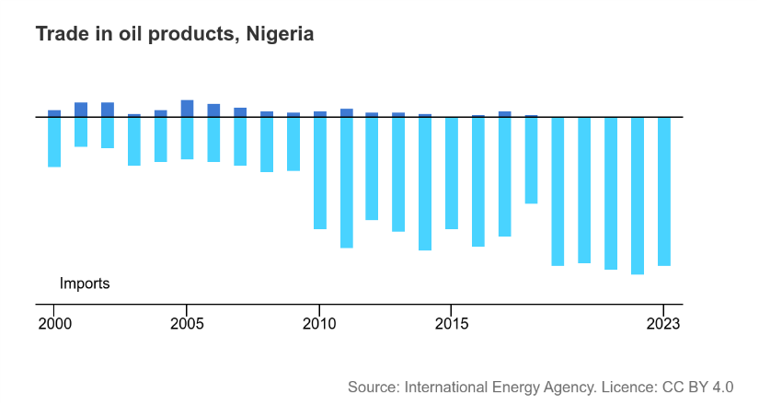
Unlike CCTs and transport subsidies—which immediately address the distributional welfare losses observed in Chapter 2—refinery investment tackles a structural vulnerability (import dependence) that lies beyond the scope of demand-side household analysis. Evaluating refinery rehabilitation's cost-effectiveness would require supply-side modeling or computable general equilibrium (CGE) analysis. Nonetheless, the logic of preventing future price shocks complements immediate compensation policies, particularly given Nigeria's chronic refinery maintenance failures and the risk of repeated subsidy crises.
Wage employment provides more economic security than informal employment. So, providing more Nigerians with jobs is a promising path to raising Nigeria’s standard of living beyond pre-reform levels. A disproportionate number of poor people globally work as entrepreneurs and perform multiple income-earning activities, although not always in agriculture. In Indonesia, Pakistan, and Nicaragua, 47-52% of households earning less than $2/day own a non-agricultural business. 47% of poor urban households in Cote d’Ivoire and Indonesia have more than one source of income. In the Udaipur district in India, nearly everyone owns land but mostly engages in subsistence agriculture. For 81% of households in Udaipur, their main source of income is non-agricultural.
In Nigeria, there is a relatively small productive population that is mainly engaged in informal, agricultural labor, with segments that are disproportionately exposed to the welfare impacts of the fuel subsidy removal. The working-age population was 116,604,860—comprising 53.8% of the total population. Roughly three-fourths (76.3%) of Nigeria’s working age population (aged 15 and over) was employed in 2023. And that work was mostly self-employed and informal. The National Bureau of Statistics identifies two main types of employment: employees and self-employment. Employees are considered those working for salaries or wages in cash or an equivalent, including paid apprentices. Self-employed people are considered those working for their own businesses with one or more partners (e.g., family members). Moreover, many Nigerians are employed in agriculture. What this means is that their jobs provide little protection from price increases in necessary goods. Very few people work for companies that can increase their wage or salary to keep up with inflation. Nigerian income is commonly acquired through informal economic transactions (see Table 3.3.1).
Table 3.3.1: Key Nigerian Labor Market Indicators: Q4 2022-Q2 2024
Key Labor Market Indicators | Q4 2022 | Q1 2023 | Q2 2023 | Q3 2023 | Q1 2024 | Q2 2024
Labor Force Participation Rate | 77.8 | 79.9 | 77.1 | 75.6 | 73.2 | 76.1
Share of employed people in self-employment | 84 | 86 | 88 | 87.3 | 84 | 85.6
Time-related unemployment | 13.7 | 12.2 | 11.8 | 12.3 | 10.6 | 9.2
Unemployment Rate | 5.3 | 4.1 | 4.2 | 5 | 5.3 | 4.3
Subsistence farmer | 5.6 | 3.9 | 4.8 | 4.1 | 4.5 | 3.7

Moreover, there is a large unemployed population. Roughly 15% of the working-age population is not working, due to being in school or receiving technical training. Also, people aged 15-24 years old had the highest unemployment rate (10.7%) in 2023 among all age groupings in the working-age population. This means that young people are disproportionately exposed to the negative welfare impacts of fuel subsidy removal. Targeted work training and internship programs would compensate for this inequality, resolve the welfare impacts of fuel subsidy removal, and raise the standard of living for more economically vulnerable Nigerians.
Work training and internship programs need to be tailored for jobs in the petroleum sector to provide an avenue for the productive reinvestment of fuel subsidy savings, whether that is excess government revenue (from petroleum product sales) or something non-monetary like increased employment and education. Employing Nigerians at the public oil refineries achieves both at the same time—it increases employment and incentivizes the need for education, and it increases the production of refined oil and decreases Nigeria’s dependence on importing petroleum at high prices on the international market.
Statistics on Nigerian employment also reveal that there is a low number of high-skilled Nigerian workers, particularly in fields relevant to the oil industry (e.g., (petro)chemical engineering). Thus, there is a need to fund educational programs that can train Nigerians in chemical and petrochemical engineering. Programs like the Petroleum Technology Development Fund scholarships, where students have their tuition, healthcare and flights paid for to pursue a Master’s or PhD in petrochemical engineering and receive job training to become future leaders in Nigeria’s oil sector are good examples of this., And lastly, capital needs to be purchased to develop the oil refineries to 100% capacity. While these three policies provide a starting framework for compensating fuel subsidy removal's welfare impacts, several limitations of the present analysis suggest directions for future research.

Limitations and Future Studies
Beyond the measurement limitations discussed in Chapter 2 (Wave 5 proxy data constraints), this study has a broader scope limitation: it focuses on microeconomic household welfare impacts using demand system analysis but does not address macroeconomic transmission mechanisms. While I demonstrate that fuel subsidy removal reduces household purchasing power and forces energy substitution, recent evidence suggests fuel price increases also triggered broader inflation, raising prices of food, transport services, and other goods., Future research could explore the empirical link between fuel price shocks, general price inflation, and aggregate consumption growth in Nigeria's post-2023 economy. Such macro-level analysis would complement this study's household-level findings and inform long-run growth projections—a key concern for policymakers justifying subsidy removal on fiscal sustainability grounds.
Additionally, the study advanced three policy responses: targeted conditional cash transfers (CCTs), reinvesting savings into refinery development and workforce training, and transportation subsidies. Future research could focus on political, administrative, and fiscal feasibility—mapping the capacity of federal, state, and local actors to implement these interventions, identifying institutional bottlenecks, and estimating the fiscal space available from subsidy savings under different oil-price scenarios. More work is needed on heterogeneity and targeting use household survey microdata and National Registry records to assess how impacts vary by region, urban versus rural areas, and income groups (especially the bottom 40%), and to measure inclusion and exclusion errors in the Registry. There also needs to be rigorous cohort testing and evaluations for each policy before scaling to larger populations: a phased or randomized CCT pilot to measure effects on consumption, poverty, registry performance, and labor supply; an urban transport subsidy or voucher pilot to observe fare and ridership responses and impacts on accessibility; and a workforce training plus internship pilot tied to refinery projects to evaluate employment and skill outcomes. And lastly, it is essential to cover and track newly impoverished populations over time.

Conclusion

Nigeria's May 2023 fuel subsidy removal represents one of Africa's most significant economic policy reforms of the decade, eliminating a fiscal burden equivalent to 2% of GDP while simultaneously exposing millions of households to severe welfare shocks. This thesis has demonstrated that the distributional impacts of this reform are profoundly unequal. It answers the central research question articulated at the outset this way: wealthy households bore the subsidy removal primarily as reduced discretionary purchasing power, while poor households experienced forced energy substitution.

Key Findings Recap
Two main empirical contributions emerge from this analysis. Methodologically, I successfully replicated Okereke et al. (2024)'s QUAIDS framework in R, validating that own-price elasticities—the key parameters determining welfare impacts—are robust across software platforms and minor specification differences (matching within 5%). This replication confirms the demand system approach as a reliable tool for analyzing fuel subsidy reforms in data-scarce contexts. Empirically, I extended this framework to Nigeria's 2023/24 household survey, the first post-reform data, revealing that fuel subsidies were highly regressive: the richest quintile captured 60% of petrol spending within energy budgets, while the bottom 50% of households consumed only 25% of total petrol expenditure. Subsidy removal triggered asymmetric energy substitution, with kerosene access collapsing 59% (from 55.2% to 22.5%), forcing many poor households to reduce modern fuel consumption. Regarding policy, I demonstrated that Nigeria's actual post-reform implementation—characterized by delayed, inadequate, and poorly targeted cash transfers—fell far short of compensating vulnerable populations, underscoring the need for comprehensive reforms combining conditional cash transfers, transportation subsidies supported by infrastructure investment, and strategic refinery rehabilitation.

Policy Implications
The findings challenge the sufficiency of simple lump-sum transfers as the sole compensatory mechanism for subsidy removal. While Okereke et al. (2024) show that targeted transfers could theoretically restore household utility, my analysis of post-reform outcomes reveals three implementation challenges that undermine this approach in practice. First, Nigeria's National Social Register covers only 12 million individuals (5.5% of the population), excluding vast swaths of vulnerable households. Second, the ₦25,000 monthly transfer (approximately $16 USD at parallel market rates) has been eroded by inflation and does not provide sufficient compensation for households facing simultaneous fuel, food, and transportation price spikes. Third, delayed disbursement and corruption in payment systems have reduced the effectiveness of transfers that do reach recipients.
These challenges motivate the tripartite policy framework I propose: (1) Conditional Cash Transfers (CCTs) tied to school enrollment and healthcare utilization, which evidence from Latin America and Sub-Saharan Africa shows can break intergenerational poverty cycles while serving as social safety nets; (2) Transportation subsidies and infrastructure investment to reduce mobility costs that disproportionately burden poor urban households, piloted through Lagos's BRT system and scaled contingent on rigorous impact evaluation; and (3) Strategic refinery rehabilitation to reduce long-term dependence on imported petroleum products, addressing the structural vulnerability that makes Nigeria—Africa's largest oil producer—a net fuel importer subject to international price volatility. Critically, this framework requires not merely fiscal resources (available from subsidy savings) but administrative capacity building, anti-corruption enforcement, and political will to prioritize long-term structural transformation over short-term palliatives.
Limitations and Future Research
As discussed in Chapter 2, this study's use of a proxy consumption aggregate (pending official Wave 5 data release) limits precise welfare loss calculation. Beyond this measurement constraint, three research directions would deepen our understanding of fuel subsidy reform impacts. First, intra-household analysis: time-use surveys could reveal whether fuel collection burdens disproportionately affect women and girls when households substitute toward traditional biomass. Second, general equilibrium effects: computable general equilibrium models or inflation pass-through analysis could quantify how fuel price shocks propagate through food prices, wages, and employment—dimensions my partial equilibrium demand system cannot capture. Third, dynamic adjustment: panel data tracking households over multiple years would reveal whether traditional fuel substitution is permanent or temporary, informing the timeline for compensatory policies.
Beyond the data measurement constraints discussed in Chapter 2, this study has two scope limitations. First, my partial equilibrium demand system analysis measures household-level welfare impacts but cannot capture macroeconomic transmission mechanisms—how fuel price increases propagate through transportation costs to affect food prices, wages, and employment. Computable general equilibrium (CGE) models could address these general equilibrium effects. Second, my analysis cannot assess intra-household welfare distribution (do women and children bear disproportionate burdens?) or long-run behavioral dynamics (do households permanently exit modern fuel markets, or gradually return?). Future research employing time-use surveys and multi-wave panel data could address these dimensions, while the release of official Wave 5 consumption aggregates (expected late 2026) would enable more precise compensating variation estimates than the proxy-based calculations presented here.
Final Reflections
Nigeria's experience offers broader lessons for subsidy reform efforts across the developing world, where governments face similar pressures to eliminate costly, regressive subsidies while protecting vulnerable populations. The evidence from this thesis suggests that timing, targeting, and comprehensiveness determine whether reforms improve or worsen distributional outcomes. Timing matters: Implementing subsidy removal during macroeconomic crises (as Nigeria did amid 30% inflation and naira devaluation) compounds welfare losses and erodes public support for reform. Targeting matters: Universal subsidies waste fiscal resources on the wealthy, but poorly designed means-testing (using incomplete registries, delayed payments, inadequate transfer amounts) fails to protect the poor. Comprehensiveness matters: Treating subsidy removal as merely a fiscal adjustment—rather than an opportunity for structural transformation addressing root causes of energy poverty—misses the chance to build long-term resilience.

U. Uwak, E. Ekpenyong, and E. Ebong, “Politics of Fuel Subsidy Regime in Nigeria and Its Implications: An Assessment of President Bola Ahmed Tinubu’s Administration,” Journal of Policy and Development Studies 17, no. 1 (2024): 54–80, https://doi.org/10.4314/jpds.v17i1.5.
KPMG, Removing Nigeria’s PMS Fuel Subsidies: We Can’t Have Our Cake & Still Eat It (2023), https://kpmg.com/ng/en/home/insights/2023/06/removing-nigeria-pms-fuel-subsidies.html.
International Monetary Fund African Dept, “Nigeria: 2022 Article IV Consultation-Press Release; Staff Report; and Statement by the Executive Director for Nigeria,” IMF Staff Country Reports, IMF Staff Country Reports 2023, no. 093 (2023), https://doi.org/10.5089/9798400232053.002.A001.
Nigeria Extractive Industries Transparency Initiative, Cost of Fuel Subsidy to the Nation: Options for Policy Review, Policy Report (Nigeria Extractive Industries Transparency Initiative, 2022), https://neiti.gov.ng/cms/wp-content/uploads/2022/12/Cost-of-Fuel-Subsidy-to-the-Nation-Options-for-Policy-Review.pdf.
Toyin Falola and Matthew M. Heaton, A History of Nigeria (Cambridge University Press, 2008), https://doi.org/10.1017/CBO9780511819711. pp. 181-182
Statistical Bulletin, no. 17 (Central Bank of Nigeria, 2006), 334, https://www.cbn.gov.ng/OUT/PUBLICATIONS/STATBULLETIN/RD/2008/STABULL-2006.PDF. pp. 95-7; 213
F. O. Okwa et al., “The Impact of Fuel Subsidy Removal on Consumer Goods in Selected States in Nigeria,” FUDMA Journal of Sciences 8, no. 5 (2024): 94–101, https://doi.org/10.33003/fjs-2024-0805-2632.
Nigeria Extractive Industries Transparency Initiative, Cost of Fuel Subsidy to the Nation: Options for Policy Review, Policy Report (Nigeria Extractive Industries Transparency Initiative, 2022), https://neiti.gov.ng/cms/wp-content/uploads/2022/12/Cost-of-Fuel-Subsidy-to-the-Nation-Options-for-Policy-Review.pdf.
Nigerian National Bureau of Statistics, Nigeria General Household Survey-Panel (Wave 5) 2023/2024: Tracking Nigerian Households to Understand Their Resilience Over Time (Nigerian National Bureau of Statistics, 2024), 161, https://microdata.worldbank.org/catalog/6410/download/180541.
World Bank, Poverty & Equity Brief: Nigeria (World Bank, 2024), https://documents.worldbank.org/en/publication/documents-reports/documentdetail/099108001062551445.
Pius Gamette and Clement Oteng, “Fuel Subsidy Removal in Global South Oil-Producing Economies: A Review of Literature,” The Extractive Industries and Society 18 (June 2024): 101468, https://doi.org/10.1016/j.exis.2024.101468.
Mary Egbo Nkechinyere et al., “Statistical Evaluation of the Effect of Fuel Subsidy Removal on Nigeria’s Economic Indicators,” Journal of Research in Applied Mathematics 11 (July 2025): 07–12.
Chukwumerije Okereke et al., Nigeria’s Fossil Fuel Subsidy Reforms: The Welfare Effects on Households (ODI, 2024), https://www.jstor.org/stable/resrep58730.
Consumer theory more broadly does assume
This is a 165% price increase in two days.
Samuel Bowles and Simon D. Halliday, Microeconomics: Competition, Conflict, and Coordination (Oxford University Press, 2022).
This makes Hicksian elasticity a key measure for calculating compensating variation.
Hal R. Varian, Intermediate Microeconomics : A Modern Approach, with Internet Archive (New York ; London : W.W. Norton & Company, 2014), http://archive.org/details/intermediatemicr0000vari_z9edo2.
An expenditure function indicates the minimum value of money a consumer requires to purchase goods from which (s)he can derive a given level of utility at a given set of prices.
Arne Henningsen, Demand Analysis with the “Almost Ideal Demand System” in R: Package micEconAids, n.d., https://cran.r-project.org/web//packages//micEconAids/vignettes/micEconAids_vignette.pdf.
Angus Deaton and John Muellbauer, “An Almost Ideal Demand System,” American Economic Review 70 (1980): 312–26.
These are covered in Henningsen, n.d.
Henningsen, Demand Analysis with the “Almost Ideal Demand System” in R: Package micEconAids.
James Banks et al., “Quadratic Engel Curves and Consumer Demand,” The Review of Economics and Statistics 79, no. 4 (1997): 527–39, https://doi.org/10.1162/003465397557015.
Naturally, a constraint for this coefficient is that the sum of baseline budget shares for all goods must equal 1. Having a total baseline budget share of 1.08 is logically impossible.
Isaac Gershon Kodwo Ansah et al., “Food Demand Characteristics in Ghana: An Application of the Quadratic Almost Ideal Demand Systems,” Scientific African 8 (July 2020): e00293, https://doi.org/10.1016/j.sciaf.2020.e00293.
Gamma and beta capture the constant marginal response to changes in price and income, whereas lambda captures the change in that response as real expenditure increases.
Jerry A. Hausman, “Exact Consumer’s Surplus and Deadweight Loss,” The American Economic Review 71, no. 4 (1981): 662–76.
Brian P. Poi, “Easy Demand-System Estimation with Quaids,” The Stata Journal 12, no. 3 (2012): 433–46, https://doi.org/10.1177/1536867X1201200306.
Budget/expenditure, own-price and cross-price elasticity measures the responsiveness of demand to changes in (1) total expenditure, (2) the price of the desired good, and (3) the price of another good respectively.
Also, note that income elasticity is not measured in Okereke et al. and should not be confused with expenditure or budget elasticity.
The LSMS was a program started by the World Bank in 1979 with the initial goal to standardize survey data collection in different countries for detecting comparable changes in poverty and other development indicators across space and time. For more information, read Angus Deaton, The Analysis of Household Surveys: A Microeconometric Approach to Development Policy.
Angus Deaton, The Analysis of Household Surveys: A Microeconometric Approach to Development Policy, Reissue (World Bank Publications, 2018), https://documents.worldbank.org/en/publication/documents-reports/documentdetail/593871468777303124. pp. 36-37
Nigeria’s National Bureau of Statistics brought the LSMS to their country with a partnership between the Nigerian Federal Ministry of Agriculture and Rural Development (FMA&RD), National Food Reserve Agency (NFRA), the Bill and Melinda Gates Foundation (BMGF) and the World Bank (WB).
It does not, however, provide reliable metrics of poverty in Nigeria. For that, you need to consult the NLSS. See Basic Information Document | Nigeria General Household Survey-Panel 2018-19 for more information.
National Bureau of Statistics (NBS), General Household Survey, Panel 2012-2013, Wave 2 [Data set], World Bank, Development Data Group, released 2014, https://doi.org/10.48529/KXPY-AA72.
National Bureau of Statistics (NBS), General Household Survey, Panel 2015-2016, Wave 3 [Data set], World Bank, Development Data Group, released 2016, https://doi.org/10.48529/7XMJ-Q133.
National Bureau of Statistics (NBS), General Household Survey, Panel 2018-2019, Wave 4 [Data set], World Bank, Development Data Group, released 2019, https://doi.org/10.48529/1HGW-DQ47.
National Bureau of Statistics (NBS), General Household Survey, Panel 2023-2024, Wave 5 [Data set], World Bank, Development Data Group, released 2024, https://doi.org/10.48529/ZD5S-TJ25.
Henningsen, Demand Analysis with the “Almost Ideal Demand System” in R: Package micEconAids.
Banks et al., “Quadratic Engel Curves and Consumer Demand.”
Jennifer Uju Okonkwo, “Welfare Effects of Carbon Taxation on South African Households,” Energy Economics 96 (April 2021): 104903, https://doi.org/10.1016/j.eneco.2020.104903.
A co-author of the Okereke et al. study directed me to the Okonkwo study after they requested for the original code to the Okereke et al. study.
To access the panels, you need to create an account with the World Bank or the National Bureau of Statistics (preferably the former) and enter a data usage agreement.
Root mean square error measures how accurate a statistical model is, with lower figures indicating higher accuracy.
Kathleen Beegle et al., “Methods of Household Consumption Measurement through Surveys: Experimental Results from Tanzania,” Journal of Development Economics, Symposium on Measurement and Survey Design, vol. 98, no. 1 (2012): 3–18, https://doi.org/10.1016/j.jdeveco.2011.11.001.
Martin Ravallion and Michael Lokshin, Rich and Powerful? Subjective Power and Welfare in Russia, Policy Research Working Paper no. 3146 (World Bank, 2005).
David Coady et al., “Chapter 14. The Unequal Benefits of Fuel Subsidies Revisited: Evidence for Developing Countries,” in Inequality and Fiscal Policy (International Monetary Fund, 2015), https://www.elibrary.imf.org/display/book/9781513531625/ch014.xml.
Beegle et al., “Methods of Household Consumption Measurement through Surveys.”
World Bank, Poverty & Equity Brief: Nigeria.
“A Model from Mexico for the World,” Text/HTML, World Bank, accessed March 26, 2026, https://www.worldbank.org/en/news/feature/2014/11/19/un-modelo-de-mexico-para-el-mundo.
Olabanji Akinola, Rethinking the Design and Implementation of Nigeria’s COPE Conditional Cash Transfer Programme, One Pager no. 330 (International Policy Centre for Inclusive Growth (IPC-IG), 2016), https://ipcig.org/pub/eng/OP330_Rethinking_the_design_and_implementation_of_Nigeria_s_COPE.pdf.
Jessica Hagen-Zanker and Rebecca Holmes, Social Protection in Nigeria: Synthesis Report (Overseas Development Institute, 2014), https://odi.org/en/publications/social-protection-in-nigeria-synthesis-report/.
Hagen-Zanker and Holmes, Social Protection in Nigeria.
These BIG amounts were at the time of launch.
The maximum BIG was NGN5000 for four or more children per month.
Akinola, Rethinking the Design and Implementation of Nigeria’s COPE Conditional Cash Transfer Programme.
Ibid.
Titilope F. Eluwa et al., “Impact of Unconditional Cash Transfers on Household Livelihood Outcomes in Nigeria,” Journal of Social Policy 54, no. 2 (2023): 595–610, https://doi.org/10.1017/S0047279423000533.
Hagen-Zanker and Holmes, Social Protection in Nigeria.
Hagen-Zanker and Holmes, Social Protection in Nigeria.
President Bola Ahmed Tinubu, “President Tinubu’s Speech at the Occasion of the International Day for the Eradication of Poverty and the Flag–off of the Renewed Hope Conditional Cash Transfer,” October 17, 2023, https://statehouse.gov.ng/president-tinubus-speech-at-the-occasion-of-the-international-day-for-the-eradication-of-poverty-and-the-flag-off-of-the-renewed-hope-conditional-cash-transfer/.
World Bank, Nigeria Development Update: Building Momentum for Inclusive Growth (World Bank, 2025), https://thedocs.worldbank.org/en/doc/18bb17d3b2d203e19fc8ecf281ed21da-0360012025/nigeria-development-update-building-momentum-for-inclusive-growth.
“World Bank Open Data,” World Bank Open Data, accessed May 13, 2026, https://data.worldbank.org.
World Bank, Poverty & Equity Brief: Nigeria.
Luis A. Guzman and Philipp Hessel, “The Effects of Public Transport Subsidies for Lower-Income Users on Public Transport Use: A Quasi-Experimental Study,” Transport Policy 126 (September 2022): 215–24, https://doi.org/10.1016/j.tranpol.2022.07.016.
Guzman and Hessel, “The Effects of Public Transport Subsidies for Lower-Income Users on Public Transport Use.”
Saidu Nasir Mohammed et al., “Impact of Fuel Subsidy Removal on the Informal Transport Sector in Sokoto State, Nigeria,” International Journal of Law, Research and Social Sciences 8, no. 11 (2023): 1–15.
Asaasuen Terngu et al., “Transportation in the Era of Fuel Subsidy Removal: An Assessment of the Cost Implication in Benue State, Nigeria,” International Journal of Development Strategies in Humanities, Management and Social Sciences 15, no. 1 (2025): 350–63, https://doi.org/10.48028/iiprds/ijdshmss.v15.i1.25.
Ken Gwilliam, Africa’s Transport Infrastructure: Mainstreaming Maintenance and Management, no. 60803, Directions in Development (World Bank, 2011), https://documents.worldbank.org/en/publication/documents-reports/documentdetail/728801468191665263.
Dayo Mobereola, Lagos Bus Rapid Transit: Africa’s First BRT Scheme, no. 95497 (World Bank, 2016), https://documents.worldbank.org/en/publication/documents-reports/documentdetail/874551467990345646.
The UN Habitat defined a megacity in 2009 as a city with over 10 million inhabitants.
Mobereola Dayo, Africa’s First Bus Rapid Transit Scheme : The Lagos BRT-Lite System (Sub-Saharan Africa Transport Policy Program, 2009), https://documents.worldbank.org/en/publication/documents-reports/documentdetail/874551467990345646.
Dayo. Africa’s First Bus Rapid Transit Scheme.
Ibid.
Agency Report, “Lagos Plans More BRT Buses to Ease Long Queues,” Punch Newspapers (Nigeria), February 4, 2025, https://punchng.com/lagos-plans-more-brt-buses-to-ease-long-queues/.
Christabel Ndoeche, “‘BRT Staff Harassed Me for Exposing Bus Shortage’, Says Lagos TikToker,” Punch Newspapers (Nigeria), March 11, 2026, https://punchng.com/brt-staff-harassed-me-for-exposing-bus-shortage-says-lagos-tiktoker/.
Asaba Metro NewsDesk, “Lagos TikToker Filming Daily BRT Struggles Alleges Harassment by Staff,” Asaba Metro News (Nigeria), March 11, 2026, https://www.asabametro.com/lagos-tiktoker-brt-harassment-bus-shortage/.
Adebayo Gbenga, “Commuters Express Mixed Reactions Over BRT Fare Hike In Lagos,” Business, Daily Trust (Nigeria), February 17, 2025, https://dailytrust.com/commuters-express-mixed-reactions-over-brt-fare-hike-in-lagos/.
Kenneth M. Gwilliam, Cities on the Move: A World Bank Urban Transport Strategy Review, World Bank Working Paper (World Bank, 2002).
“Nigeria - Countries & Regions,” IEA, International Energy Agency, accessed May 17, 2026, https://www.iea.org/countries/nigeria.
Godwin Orluchukwu and Thankgod Lilly-Inia, “Fuel Subsidy Removal in Nigeria: Problems and Prospects,” Journal of Policy and Development Studies 17, no. 2 (2025): 92–108, https://doi.org/10.4314/jpds.v17i2.7.
International Energy Agency, “Nigeria - Countries & Regions.”
Agaptus Nwozor et al., “The Dialectics of Nigeria’s Opaque Downstream Oil Sector and the Agency of Fuel Subsidy,” Pertanika Journal 32, no. 2 (2024): 735–60, https://doi.org/10.47836/pjssh.32.2.18.
Abhijit V. Banerjee and Esther Duflo, “The Economic Lives of the Poor,” Journal of Economic Perspectives 21, no. 1 (2007): 141–68, https://doi.org/10.1257/jep.21.1.141.
Banerjee and Duflo, “The Economic Lives of the Poor.” p. 155.
This low-working age population is partially due to a higher-than-average number child births and infant mortality rate in Africa compared to the rest of the world, leaving a large population of young people.
Nigerian National Bureau of Statistics, Nigeria Labour Force Survey (NLFS) Report Q2 2024 (Nigerian National Bureau of Statistics, 2024), https://microdata.nigerianstat.gov.ng/index.php/catalog/152.
Nigerian National Bureau of Statistics, Nigeria Labour Force Survey (NLFS) Report Q2 2024.
OpeOluwani Akintayo, “FG Opens Applications For PTDF-Funded 2026 Overseas Scholarships,” Channels Television, January 20, 2026, https://www.channelstv.com/2026/01/20/fg-opens-applications-for-ptdf-funded-2026-overseas-scholarships/.
“PTDF - Petroleum Technology Development Fund,” accessed April 12, 2026, https://ptdf.gov.ng/about-us.
Egbo et al., “Statistical Evaluation of the Effect of Fuel Subsidy Removal on Nigeria’s Economic Indicators.”
Sesan Sunday Abere, “Asymmetric Impacts of Exchange Rate and Petroleum Pump Price on Economic Welfare in Nigeria,” Economic Journal of Emerging Markets, 2025, 219–34, https://doi.org/10.20885/ejem.vol17.iss2.art8.
World Bank, Nigeria Development Update: Building Momentum for Inclusive Growth.

